



**Course title:** Numerical Methods.

**Assignment on:** Least squares curve fitting procedures.

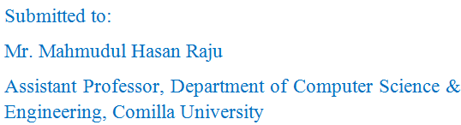

Date of Submission: 12-04-2016

Submitted by:

